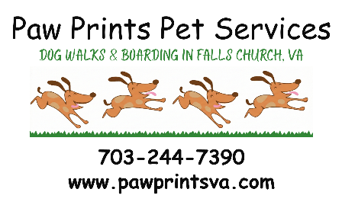

Rates & Services (legacy) Paw Prints Pet Services LLC
VISIT TYPE RATE (PER VISIT)  Initial Consultation FREE  Regular $27  Express $21  45 Minutes $40  1 hour $50  Pet Lodging* $80 per night per dog  Daycare $45 per dog  Drop-In $10  Transportation $20  ADDITIONAL FEES RATE (per visit/occurrence)  Bounced Check $20  Late Payment 30 days past due $15  Holidays Extra $5 per visit  After Hours _{Before 8 AM or after 8 PM} Extra $5 per visit  No extra charges for multiple pets for dog walking, pet sitting or cat care  * Pet Lodging is per pet, per night Additional $10 per night for puppies or seniors requiring extra care & clean up  All visits are scheduled within a 3 hour preferred service window.  Federal holidays require an extra fee and may not be available for scheduling.  Rates subject to change.  Pricing effective 11/2026 | Initial Booking Consultation 30-60 minutes  At this visit we can complete the necessary paperwork, answer questions, transfer keys, and meet your pet while discussing detailed instructions for the care of your pet(s).  Regular Visit 25-30 Minutes  Our most popular choice. Allows for a good walk and/or play time and some extra attention for your pet.  Express Visit 10-15 Minutes  Can be used as a quick potty break, short walk, litter box cleaning, easy keeper care, or even a 3rd feeding.  Drop-In 3 Minutes or less  Short drop in to transfer keys (pick up or drop off), check iron/stove, turn off sprinkler system, close windows, etc.  Pet Lodging (boarding)  Available on a case by case basis. Your dog would stay at your sitter’s home and would include all necessary care, feeding & walks plus some extra TLC!  Daycare  Available on a case by case basis. All necessary care between 8 AM – 8 PM.  Transportation  Pick up or drop off your pet for lodging/daycare or other locations within 5 miles.  Please schedule adequate time to provide the services requested. If your pet needs more time than scheduled, it will be added as needed and billed to you.  Important Terms  Payment is due on receipt when invoiced. Cash preferred. Checks, PayPal, or Zelle gratefully accepted.  Cancellations must be received by 9 AM the day of service or visit will be charged in full.

